Data Visualization Techniques and Tools
A Research Report
Submitted in partial fulfillment of the
Requirements for the award of the Degree of
MSATER OF SCIENCE (INFORMATION TECHNOLOGY)
By
Ahmed Dilshad Shaikh
Roll Number: 812
Under the esteemed guidance of
Ms. Kirti Yadav
Designation

DEPARTMENT OF INFORMATION TECHNOLOGY
SHRI RAJASTHANI SEVA SANGH’S
SMT.PARMESHWARIDEVI DURGADUTT TIBERWALA LIONS JUHU COLLEGE OF ARTS, COMMERCE & SCIENCE
(Affiliated to University of Mumbai)
(Autonomous)
JB NAGAR, ANDHERI EAST, MUMBAI MAHARASHTRA - 400059
2025 - 26

 | Sr. No. | Contents | Page No.
Chapter | 1 | INTRODUCTION | 3
Chapter | 2 | IMPORTANCE OF DATA VISUALIZATION | 5
Chapter | 3 | DATA VISUALIZATION TECHNIQUES | 5
Chapter | 4 | DATA VISUALIZATION TOOLS | 6
Chapter | 5 | CONCLUSION | 7
TABLE OF CONTENTS

CHAPTER - 1

INTRODUCTION
In recent years, data has become one of the most valuable resources for organizations, researchers, and governments. However, raw data by itself does not provide meaningful information unless it is analyzed and presented properly. Data visualization refers to the graphical representation of data and information using visual elements such as charts, graphs, infographics, and dashboards. It enables users to understand complex data easily by converting numerical and textual information into visual form.
In the context of research methodology, data visualization plays a vital role in data analysis, interpretation, and presentation of research findings. It bridges the gap between complex data processing and human understanding. With the rapid growth of big data and advanced analytics, data visualization tools and techniques have become more interactive and widely used in various fields such as business, healthcare, education, and scientific research.

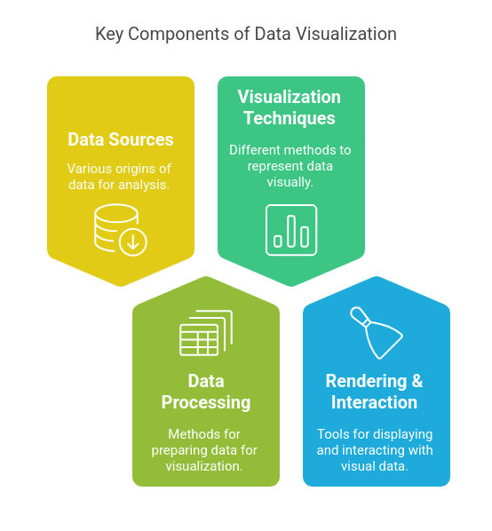

CHAPTER - 2

IMPORTANCE OF DATA VISUALIZATION
The importance of data visualization lies in its ability to simplify large and complex datasets and present them in an intuitive and understandable manner. Visual representations allow researchers and decision-makers to quickly grasp insights that might otherwise remain hidden in raw data.
Data visualization improves decision-making by enabling faster analysis and comparison of information. It enhances communication by presenting research results in a visually appealing and clear format. Visualization also supports exploratory data analysis by helping researchers identify trends, correlations, and anomalies effectively. As a result, data visualization has become an indispensable tool in modern research methodology.

CHAPTER - 3
DATA VISUALIZATION TECHNIQUES
Data visualization techniques can be broadly classified into basic, statistical, and advanced techniques. Basic visualization techniques include bar charts, line charts, pie charts, and tables. These techniques are commonly used for comparing values, showing trends over time, and representing proportions.
Statistical visualization techniques such as histograms, box plots, and scatter plots are used to understand data distribution, variation, and relationships between variables. These techniques are especially useful in research studies involving numerical and statistical analysis.
Advanced visualization techniques include heat maps, tree maps, network graphs, and dashboards. Heat maps use color intensity to represent values, while tree maps display hierarchical data. Dashboards combine multiple visual elements into a single interface, allowing users to monitor and analyze data in real time. These advanced techniques are widely used in business intelligence and big data analytics.

CHAPTER - 4
DATA VISUALIZATION TOOLS

Several tools are available for creating effective and interactive data visualizations. Tableau is one of the most popular business intelligence tools, known for its user-friendly drag-and-drop interface and powerful dashboard features. It allows users to create interactive and dynamic visualizations with minimal technical knowledge.
Microsoft Power BI is another widely used tool that integrates well with Microsoft products and supports real-time data visualization. Programming-based tools such as Python and R are extensively used in data science and academic research. Python libraries like Matplotlib, Seaborn, and Plotly provide flexible visualization options, while R’s ggplot2 is popular for statistical visualization. Spreadsheet tools such as Microsoft Excel and Google Sheets are also commonly used for basic visualization tasks.

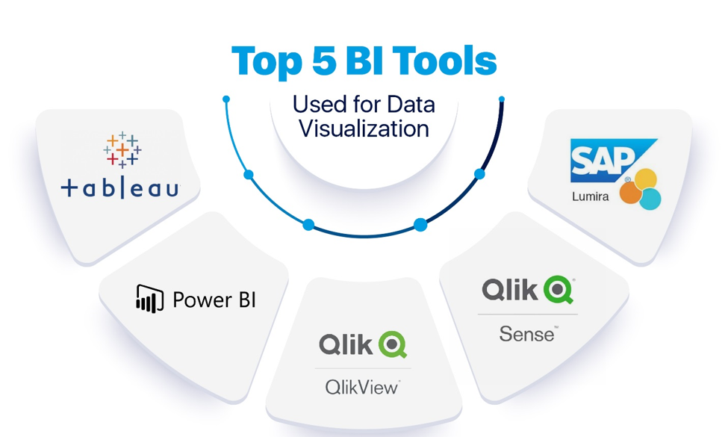

CHAPTER - 5
CONCLUSION
Data visualization plays a vital role in modern research methodology and data analysis by transforming raw and complex data into meaningful visual representations. In this research paper, various aspects of data visualization were discussed, including its importance, commonly used techniques, and popular visualization tools. The study highlights how charts, graphs, dashboards, and other visual elements help researchers and decision-makers understand large datasets more effectively.
The paper also emphasizes that data visualization improves decision-making, enhances communication of research findings, and supports exploratory data analysis by identifying patterns, trends, and relationships within data. Tools such as Tableau, Power BI, Python, R, and Excel have made data visualization more accessible, interactive, and efficient across different domains.
In conclusion, data visualization is an indispensable component of research and data-driven environments. With continuous advancements in technology, including artificial intelligence and real-time analytics, the scope of data visualization is expected to grow further. Effective use of data visualization techniques and tools will continue to support better research outcomes and informed decision-making in the future.

